|  |  |  |  |  |
| --- | --- | --- | --- | --- |
|  |  | | |  |
|  |  | | |  |
|  | Fog Lights | | |  |
|  | (F001010) | | |  |
|  |  | | |  |
|  |  | | |  |
| Document Type | **Feature Document (FD)** | | |  |
| Template Version | **6.1b** | | |  |
| Document ID | **Fog Lights\_2.0fd - fog lights** | | |  |
| Document Location | **[VSEM Link](https://www.vsemweb.ford.com/tc/launchapp?-attach=true&-s=226TCSession&-o=jItFpjdbx3NrTDAAAAAAAAAAAAA&servername=Production_Server)** | | |  |
| Document Owner | **Eric Vieira and Lucas Santos** | | |  |
| Document Revision | **1.0** | | |  |
| Document Status | **Released** | | |  |
| Date Issued | **2021-12-03** | | |  |
| Date Revised | **2021-12-03** | | |  |
| Document Classification | GIS1 Item Number: | **27.60/35** | |  |
| GIS2 Classification: | **Confidential** | |
|  | | | | |
|  | | | | |
| Document Approval | | | | |
| Person | Role | | Email Confirmation | Date |
|  |  | |  |  |
|  |  | |  |  |

This document contains Ford Motor Company Confidential information. Disclosure of the information contained in any portion of this document is not permitted without the expressed, written consent of a duly authorized representative of Ford Motor Company, Dearborn, Michigan, U.S.A.

Copyright © 2016 - 2020, Ford Motor Company

Printed Copies Are Uncontrolled

**How to Use this Template**

Follow the [RE process definition](https://bd101001.pd2.ford.com/stages/" \l "/workspace/209/_vv/(process/activity/_S-Rj8EHW_KKHa9Bz6IpdSw)) in Stages for [Creating a Feature Definition](https://bd101001.pd2.ford.com/stages/" \l "/workspace/209/_vv/(process/activity/_VsOScGqJVwi5zd82DgHb6g)) to derive the information relevant for this document.

To get more information about the RE information model and the Concept, Logical and Technology abstraction level refer to the [Ford RE Wiki](http://wiki.ford.com/display/RequirementsEngineering/Requirements+Engineering+for+SW+Enabled+Features). For details on the Ford Functional Safety (ISO26262) process refer to the [Ford Functional Safety Sharepoint](https://azureford.sharepoint.com/sites/GlobalFunctionalSafety/Pages/default.aspx).

**Important:**

Use only these RE specification macros to create/insert requirements in this specification. Use of RE specification macros is a prerequisite for seamless VSEM import of the specification content.

Download RE\_SpecificationMacroTemplate.dotm from chapter “Utilities” on [page “Specification Templates” in the RE Wiki](http://wiki.ford.com/display/RequirementsEngineering/Specification+templates) and follow instructions at “[How to use the Specification Templates](http://wiki.ford.com/display/RequirementsEngineering/How+to+use+the+Specification+Templates?src=contextnavpagetreemode)” on how to enable and use the macros and the requirements templates in this specification.

Once the specification is complete it should be imported to VSEM (refer to ["How to import specifications into VSEM as separate requirements"](http://wiki.ford.com/pages/viewpage.action?pageId=104991616&src=contextnavpagetreemode)).

# Contents

[Contents 3](#_Toc89439526)

[1 Introduction 5](#_Toc89439528)

[1.1 Document Purpose 5](#_Toc89439529)

[1.2 Document Scope 5](#_Toc89439530)

[1.3 Document Audience 5](#_Toc89439531)

[1.3.1 Stakeholder List 5](#_Toc89439532)

[1.4 Document Organization 6](#_Toc89439533)

[1.4.1 Document Context 6](#_Toc89439534)

[1.4.2 Document Structure 6](#_Toc89439535)

[1.5 Document Conventions 6](#_Toc89439536)

[1.5.1 Classification of Chapters 6](#_Toc89439537)

[1.5.2 Requirements Templates 7](#_Toc89439538)

[1.6 References 7](#_Toc89439539)

[1.6.1 Ford Documents 7](#_Toc89439540)

[1.6.2 External Documents and Publications 7](#_Toc89439541)

[1.7 Glossary 7](#_Toc89439542)

[1.7.1 Definitions 8](#_Toc89439543)

[1.7.2 Abbreviations 8](#_Toc89439544)

[1.7.3 Parameters / Values 9](#_Toc89439545)

[2 Feature Overview 10](#_Toc89439546)

[2.1 Purpose and Description of Feature 10](#_Toc89439547)

[2.2 Feature Variants 11](#_Toc89439548)

[2.2.1 Regions & Markets 11](#_Toc89439549)

[2.3 Input Requirements/Documents 11](#_Toc89439550)

[2.4 Lessons Learned 13](#_Toc89439551)

[2.5 Assumptions 13](#_Toc89439552)

[3 Feature Context 14](#_Toc89439554)

[3.1 Feature Context Diagram 14](#_Toc89439555)

[3.2 List of Influences 14](#_Toc89439558)

[4 Feature Modeling 15](#_Toc89439561)

[4.1 Operation Modes and States 15](#_Toc89439562)

[4.2 Use Cases 17](#_Toc89439638)

[4.2.1 Use Case Diagram 17](#_Toc89439639)

[4.2.2 Actors 18](#_Toc89439649)

[4.3 Driving and Operation Scenarios 19](#_Toc89439650)

[4.4 Decision Tables 20](#_Toc89439651)

[5 Feature Requirements 21](#_Toc89439653)

[5.1 Front Fog Functional Requirements 21](#_Toc89439654)

[5.2 Rear Fog Functional Requirements 22](#_Toc89439794)

[5.3 Non-Functional Requirements 22](#_Toc89439834)

[5.3.1 Safety 22](#_Toc89439835)

[5.3.2 Security 22](#_Toc89439837)

[5.3.3 Reliability 22](#_Toc89439840)

[5.4 HMI Requirements 23](#_Toc89439874)

[5.5 Other Requirements 24](#_Toc89439914)

[5.5.1 Design Requirements 24](#_Toc89439915)

[5.5.2 Manufacturing Requirements 24](#_Toc89439917)

[5.5.3 Service Requirements 24](#_Toc89439918)

[5.5.4 After Sales Requirements 24](#_Toc89439919)

[5.5.5 Process requirements 24](#_Toc89439920)

[6 Functional Safety 25](#_Toc89439921)

[6.1 System Behaviors for HARA 25](#_Toc89439922)

[6.2 Functional Safety Assumptions 25](#_Toc89439923)

[6.3 Safety Goals 26](#_Toc89439924)

[6.4 Functional Safety Requirements 27](#_Toc89439965)

[6.4.1 Derivation of Functional Safety Requirements on Assumptions 27](#_Toc89439966)

[6.4.2 ASIL Decomposition of Functional Safety Requirements 27](#_Toc89439967)

[7 Cybersecurity 28](#_Toc89439969)

[8 Architecture 29](#_Toc89439970)

[8.1.1 Functions 30](#_Toc89439971)

[8.2 Logical Architecture 31](#_Toc89439972)

[8.2.1 Logical Elements 32](#_Toc89439973)

[8.2.1 Logical Interfaces 33](#_Toc89439974)

[9 Traceability Matrix 35](#_Toc89440077)

[10 Open Concerns 37](#_Toc89440078)

[11 Revision History 38](#_Toc89440079)

[12 Appendix 39](#_Toc89440081)

**List of Figures**

[Figure 1: Front Fog Light Feature Image 10](#_Toc89440082)

[Figure 2: Rear Fog Light Feature Image 10](#_Toc89440083)

[Figure 3**: Fog Ligh**ts **Feature Context Diagram** 14](#_Toc89440084)

[Figure 4: Fog Feature Operation Modes and States 15](#_Toc89440085)

[Figure 5: Use Case Diagram 17](#_Toc89440086)

[Figure 8: Functional Boundary Behavior 29](#_Toc89440087)

[Figure 9: Logical Architecture 31](#_Toc89440088)

**List of Tables**

[Table 1: Features described in this FD 5](#_Toc89440089)

[Table 2: Ford internal Documents 7](#_Toc89440090)

[Table 3: External documents and publications 7](#_Toc89440091)

[Table 4: Definitions used in this document 8](#_Toc89440092)

[Table 5: HMI Fog and Headlamp Switches 8](#_Toc89440093)

[Table 6: Abbreviations 8](#_Toc89440094)

[Table 7: Parameters / Values used in this document 9](#_Toc89440095)

[Table 8: Feature Variants 11](#_Toc89440096)

[Table 9: Regions & Markets 11](#_Toc89440097)

[Table 10: Input Requirements/Documents 13](#_Toc89440098)

[Table 11: List of Influences for Fog Lights 14](#_Toc89440099)

[Table 12: Operation Modes and States 16](#_Toc89440100)

[Table 13: Transitions between Operational Modes and States 17](#_Toc89440101)

[Table 14: List of Actors 18](#_Toc89440102)

[Table 15: Front Fog Light Decision Table 20](#_Toc89440103)

[Table 16: Rear Fog Light Decision Table 20](#_Toc89440104)

[Table 17: System Behaviors for HARA 25](#_Toc89440105)

[Table 18: System Behaviors for HARA 25](#_Toc89440106)

[Table 19: Functional Safety Assumptions for FRONT FOG 26](#_Toc89440107)

[Table 20: Functional Safety Assumptions for REAR FOG 26](#_Toc89440108)

[Table 16: List of Functions 30](#_Toc89440109)

[Table 19: Logical Elements 32](#_Toc89440110)

[Table 18: Feature Interactions 34](#_Toc89440111)

[Table 21: Open Concerns 37](#_Toc89440112)

# Introduction

## Document Purpose

A Feature Document (FD) document defines a Feature on [Concept Level](https://bd101001.pd2.ford.com/stages/" \l "/workspace/209/_vv/(process/activity/_Y6ftAPI2VsW5zd82DgHb6g)). It specifies **what** the feature shall do and how it shall behave from customer perspective. It should also provide reasoning and background **why** we have the feature in the vehicle.

The FD also serves as an Item Definition as defined by ISO26262 for those features, which follow the Ford Functional Safety process. Refer [FFSG01.10 Feature Document Guideline](https://azureford.sharepoint.com/sites/GlobalFunctionalSafety/Released%20Templates%20Guidelines%20and%20Examples/Guidelines/FFSG01.10_FeatureDocument_Guideline.pdf) for how to apply the Feature Doc template for Functional Safety.

## Document Scope

A Feature Document (FD) document specifies **what** the feature shall do and how it shall behave from customer perspective. It should also provide reasoning and background **why** we have the feature in the vehicle.

The FD also serves as an Item Definition as defined by ISO26262 for those features, which follow the Ford Functional Safety process.

This Feature Document (FD) specifies the following features:

|  |  |  |  |
| --- | --- | --- | --- |
| **Feature ID** | **Feature Name** | **Owner** | **Reference** |
| F001010/C | Fog Lights | Eric Vieira (EVIEIRA1) | https://www.vsemweb.ford.com/tc/launchapp?-attach=true&-s=226TCSession&-o=jItFpjdbx3NrTDAAAAAAAAAAAAA&servername=Production\_Server |

Table 1: Features described in this FD

## Document Audience

The FD is written by the feature owner Eric Vieira (EVIEIRA1). All Stakeholders, i.e., all people who have a valid interest in the feature should read and, if possible, review the FD. It needs to be guaranteed, that all stakeholders have access to the currently valid version of the FD.

**#Hint:** The FD template has the IP Classification “Proprietary” by default. IP Classification “Confidential” might be required in some cases, e.g. by Ford Functional Safety.

**#Macro:** [Add Ins -> Edit Document Properties macro](https://wiki.ford.com/pages/viewpage.action?pageId=174654255) (select “Proprietary” for “Document Classification”)

### Stakeholder List

For the latest list of stakeholders of the feature and their influence refer to [F001010/C VSEM Folder](https://www.vsemweb.ford.com/tc/launchapp?-attach=true&-s=226TCSession&-o=jItFpjdbx3NrTDAAAAAAAAAAAAA&servername=Production_Server).

|  |  |  |  |  |
| --- | --- | --- | --- | --- |
| **Name** | **CDSID** | **Contact Info** | **Role** | **Stakeholder Group** |
| Eric Aleksander Vieira | EVIEIRA1 | [evieira1@ford.com](mailto:evieira1@ford.com) | Core Feature Owner | Systems Engineering |
| Nicolás Gagliardi | NGAGLIA2 | [ngaglia2@ford.com](mailto:ngaglia2@ford.com) | Model Architect | Model Based System Engineering |
| Lucas Santos | LSANT318 | [lsant318@ford.com](mailto:lsant318@ford.com) | Core Feature Owner | Systems Engineering |
| Jeff Mesko | JMESKO | [jmesko@ford.com](mailto:jmesko@ford.com) | Core Lighting Feature/Function Engineer | Core Lighting |
| Herta Lusho | HLLUSHO | [hllusho@ford.com](mailto:hllusho@ford.com) | Core Lighting | Core Lighting |
| Anthony Strzelczyk | ASTRZELC | [astrzelc@ford.com](mailto:astrzelc@ford.com) | Core Lighting | Core Lighting |

## Document Organization

### Document Context

Refer to the [Specification Structure page](http://wiki.ford.com/display/RequirementsEngineering/Specification+templates) in the [Ford RE Wiki](http://wiki.ford.com/display/RequirementsEngineering/Requirements+Engineering+for+SW+Enabled+Features) to understand how the FD relates to other Ford Requirements Documents and Specifications.

### Document Structure

The structure of this document is explained below:

**Introduction** – Explains how to use this document including responsibilities and requisite documents. Explains the terminology. Gives a clarification of the definitions, concepts and abbreviations used in the document.

**Feature Overview** – States briefly the background and the purpose of the feature, feature variants and corresponding regions and markets. Also includes input requirements, assumptions and constraints.

**Feature Context** – describes all external entities, which have an influence on the feature.

**Feature Modeling** – Contains Use Case, Driving Scenarios, State Charts to describe the functional behavior of the feature.

**Feature Requirements** – Lists functional and non-functional requirements of the feature.

**Functional Safety** – Lists System Behaviors, Safety Goals and Safety Requirements of the feature.

**Cybersecurity**  – Lists Security Goals and Security Requirements of the feature.

**Architecture** – Shows the coarse architecture, which the feature requirements are deployed to. Describes the elements and the boundary of the feature as well as the decomposition and distribution of associated functions.

**Traceability Matrix** – Traceability Matrix.

**Open Concerns** – List of Open Concerns

**Revision History** – Document Change History including a list of new or modified requirements. The requirements in this document are tagged, and this section contains different types of tables listing all, new, or changed requirements by their title and page no.

**Appendix** – Appendix

## Document Conventions

### Classification of Chapters

A chapter is considered mandatory, unless the chapter or its parent chapter(s) are categorized by using the tag:

**#Classification:** Some Condition

If no requirement/other content is known for a mandatory chapter, leave a statement “Not Applicable”

Some chapters have a follow certain rules in context of specific Ford processes, e.g. Functional Safety. This is indicated at the beginning of the corresponding chapter by the tags:

**#Functional Safety:** Some process specific explanation

**#Cybersecurity:** Some process specific explanation

### Requirements Templates

Refer to “[How to use the Specification Templates](http://wiki.ford.com/display/RequirementsEngineering/How+to+use+the+Specification+Templates?src=contextnavpagetreemode)” on how to use the specification templates and the VBA macros to create/edit the requirements in the specifications.

#### Identification of requirements

The unique requirement ID given in the headline of any requirement follows the requirement throughout the development process. The requirement ID format follows a well-defined syntax.

All identifiers in a FD shall be composed of 4 parts:

* A leading prefix, which indicates the type of requirement (R=Requirement, UC=Use Case, SC=Scenario, …)
* A prefix, which indicates the abstraction level (F=Feature, FNC=Function, CMP = component).
* Followed by a name, indicating the scope, which the requirement belongs to (e.g. feature or function name )
* Ending with the actual requirement number

*Example:*

*R\_F\_AutoLamps\_00004* This is the fourth requirement on feature level for the feature Autolamps.

#### Requirements Attributes

The templates provided by *Specification\_Macros.dotm* define a list of attributes for each requirement. This helps to classify the requirement. The attributes are explained at [RE Wiki - Requirements Attributes](http://wiki.ford.com/display/RequirementsEngineering/Requirements+Attributes?src=contextnavpagetreemode).

## References

### Ford Documents

List here all Ford internal documents, which are directly related to the feature.

| **Reference** | **Title** | **Doc. ID** | **Document Location** | **Revision** |
| --- | --- | --- | --- | --- |
| [FFSG01.10] | FFSG01.10 Feature Document Guideline | FFSG01.10 | <https://azureford.sharepoint.com/sites/GlobalFunctionalSafety/Released%20Templates%20Guidelines%20and%20Examples/Guidelines/FFSG01.10_FeatureDocument_Guideline.pdf> |  |

Table 2: Ford internal Documents

### External Documents and Publications

The list of external documents could include books, reports and online sources.

**#Hint:** You may refer to [IEEE Citation Reference](http://www.ieee.org/documents/ieeecitationref.pdf) on how to format a reference.

| **Reference** | **Document / Publication** | **Document Location** |
| --- | --- | --- |
|  |  |  |
|  |  |  |

Table 3: External documents and publications

## Glossary

**#Hint**: Terms, concepts and abbreviations used in the document shall be defined and illustrated here. Note that changes to terms and/or concepts described in this section tend to cause major updates to this document.

The tables below have feature specific definitions and abbreviations. For additional, non-feature specific terms please refer to the [RE Glossary](https://wiki.ford.com/display/RequirementsEngineering/RE+Glossary)

### Definitions

| **Definition** |  | **Description** | |
| --- | --- | --- | --- |
|  |  |  | |
|  |  |  | |

Table 4: Definitions used in this document

| **Part ID** |  | **Description** |
| --- | --- | --- |
| 13D061 - Master Lighting Control Switch (or MLS) |  | This is the multi-position switch on the panel inside the vehicle. Usually located on the left side of the steering column. Typical configuration: Separate push button Fog Switches (Front and/or Rear). Rotary switch positions: OFF, POSITION/ PARKLAMPS, HEADLAMP (LOW BEAM), and AUTOLAMP. Note: POSITION is the same as PARKLAMPS but the term POSITION is used in EU markets. |
| 14B522 - Hi/Lo Beam Headlamp Stalk Switch |  | This is the turn signal stalk which incorporates the Hi/Lo Headlamp switch. Push forward to activate high beams, push again to turn the high beams off. Flash to Pass by pulling the stalk towards you. |
| Center Stack Touch Screen |  | This is the Center stack touch screen that incorporates Front and Rear Fog lights activation / deactivation. Fog Lights shall be activated via touch screen interface (soft button). Pressing the screen button to activate the Fog Lamps on. Pressing the screen button again to turn them off. |

Table 5: HMI Fog and Headlamp Switches

### Abbreviations

| **Abbr.** | **Stands for** | **Description** |
| --- | --- | --- |
| FFL | Front Fog Light |  |
| RFL | Rear Fog Light |  |
| MLS | Master/Main Light Switch | Head Lamp Switch |
| HMI | Human Machine Interface | Switches or touch screens, etc. |
| IP or IPC | Instrument Panel or Instrument Cluster | Vehicle operators’ visual feedback of the vehicle’s operation |
| BCM | Body Control Module |  |
| SCCM | Steering Column Control Module |  |
| FSR | Function Safety Requirements | ISO 26262 Related Requirements |
| FD | Feature Document | This document describes the feature basics |
| FS | Functional Specification | The document describing, collecting and developing the requirements of a function or a group of functions. |
| FIS | Feature Implementation Spec | Details how the feature is implemented in software |
| FSM | Functional State Machine | Used to reference a state machine flow chart in the BCM |

Table 6: Abbreviations

### Parameters / Values

| **Name** | **Description** | **Range / Resolution** |
| --- | --- | --- |
| **FrontFog\_AutoCancel\_Cfg** | NO\_CANCEL for US/Canada, CANCEL set for rest of world | CANCEL/NO\_CANCEL |
| **FrontFog\_WithHighBeams\_Cfg** | front fog lamps allowed when high beam headlamps are on – INHIBIT for U.S. and Canada, ALLOW for rest of world | INHIBIT/ALLOW |

Table 7: Parameters / Values used in this document

# Feature Overview

## Purpose and Description of Feature

The Front Fog Lighting can be provided by halogen or Light Emitting Diode (LED) light bulbs. Front Fog Lights are optional and not required in any market.

The primary goal of Front Fog Light Feature is to provide better up-front lighting for the driver during adverse weather conditions. An indicator telltale is illuminated whenever the front fog lamps are illuminated due to this feature. The FFL feature activation and intensity are governed by regulations.

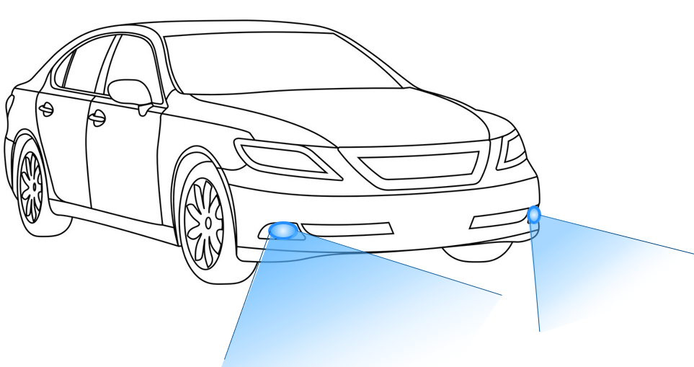 

Figure 1: Front Fog Light Feature Image

Rear Fog lights are provided to give additional lighting to the rear of the vehicle and are only to be used in conditions of severely reduced visibility. They consist of either one (mounted on the centerline or driver’s side of the vehicle) or two high intensity red lamps, to improve visibility of the vehicle to drivers approaching from the rear. RFL feature is meant for European and China applications only. For North America this feature is not installed. An indicator telltale is illuminated whenever the RFL are illuminated due to this feature.

Rear Fog Lamp can be on one side or on both sides of the vehicles rear lighting. A single sided fog lamp is shown in the figure below as an example.

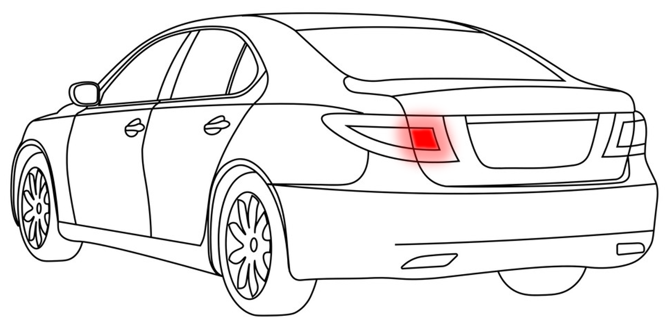 

Figure 2: Rear Fog Light Feature Image

## 

## Feature Variants

|  |  |  |
| --- | --- | --- |
| Variant Name | Variant Description | Remarks |
| **Front Fog Light** | Forward facing lamps that illuminate the area close to and in front of the vehicle for better visibility to the driver in adverse weather conditions. |  |
| **Rear Fog Lights** | Rearward facing lamp(s) to improve visibility of the vehicle to other drivers during adverse weather conditions. |  |

Table 8: Feature Variants

### Regions & Markets

|  |  |  |  |  |  |  |  |
| --- | --- | --- | --- | --- | --- | --- | --- |
|  | | **United States** | **Canada** | **Europe** | **China** | **Argentina** | **Brazil** |
| **Front Fog Light** | **Applicability** | Optional2 | | Optional3 | | | |
| **Regulations** | FMVSS 101 | CMVSS 101 | R19 | GB 4660 | Decree 779 Annex I | Res. No. 227 |
| SAE J583 | | R37 | GB 15766.1 | Contran Res. No. 667 |
| SAE J578 | | R48 | GB 4785 | Contran Res. No. 758 |
|  | | R112 |  |  |
| R121 |
| **Rear Fog Light** | **Applicability** | Optional1 | | Mandatory | | Optional1 | |
| **Regulations** | FMVSS 101 | CMVSS 101 | R37 | GB 11554 | Decree 779 Annex I | Res. No. 227 |
| SAE J583 | | R38 | GB 4785 | Contran Res. No. 667 |
| SAE J578 | | R48 | GB 15766.1 | Contran Res. No. 758 |
|  | | R112 |  |  |
| R121 |
| R148 |
|  |  | 1. Regulatory optional but not implemented at Ford | | |  |  |  |
|  |  | 2. Can only be activated when the parking lamps are on (i.e. parking lamps, low beams, or high beams) | | | | | |
|  |  | 3. Can be activated independent of low beam and high beam | | | |  |  |



Table 9: Regions & Markets

## Input Requirements/Documents

|  |  |  |  |
| --- | --- | --- | --- |
| **Reference**  (Reference as listed in ch. “References) | **Section/Requirement** | **Description** | **Derived Requirement**  (optional – reference to requirement in ch. “Feature Requirements”) |
| **Attribute Requirements** | | | |
|  | R\_AT\_FL\_00001 HMI Request | Fog Lights feature shall be activated/deactivated by user request via HMI when preconditions are met. |  |
|  | R\_AT\_FL\_00002 Deactivation by preconditions | Fog Lights feature shall turn off when any preconditions are not met |  |
|  | R\_AT\_FL\_00003 Provide Illumination / Warning signal | The primary goal of Fog Lights feature is to improve visibility due to adverse environmental conditions, such as fog.  It is achieved by providing additional light at the front of the vehicle and providing a visual of the rear of the vehicle for other drivers. |  |
|  | R\_AT\_FL\_00004 Fog Lights indicate activation by Telltale | When Fog Lights are activated, the HMI shall give an immediate visual feedback. |  |
| **Ford Engineering Standards** | | | |
|  |  |  |  |
|  |  |  |  |
| **Legal Regulations** | | | |
| USA | **FMVSS 101** | CONTROLS AND DISPLAYS |  |
| USA/Canada | **SAE J583** | FRONT FOG LAMP |  |
| USA/Canada | **SAE J578** | CHROMATICITY REQUIREMENTS FOR GROUND VEHICLE LAMPS AND LIGHTING EQUIPMENT |  |
| Canada | **CMVSS 101** | CONTROLS AND DISPLAYS |  |
| ECE | **R19** | POWER-DRIVEN VEHICLE FRONT FOG LAMPS |  |
| ECE | **R37** | UNIFORM PROVISIONS CONCERNING THE APPROVAL OF: FILAMENT LIGHT SOURCES FOR USE IN APPROVED LAMP UNITS OF POWER-DRIVEN VEHICLES AND OF THEIR TRAILERS |  |
| ECE | **R38** | REAR FOG LAMPS FOR POWER-DRIVEN VEHICLES AND THEIR TRAILERS |  |
| ECE | **R48** | VEHICLES WITH REGARD TO THE INSTALLATION OF LIGHTING AND LIGHT-SIGNALLING DEVICES |  |
| ECE | **R112** | MOTOR VEHICLE HEADLAMPS EMITTING AN ASYMMETRICAL PASSING-BEAM OR A DRIVING-BEAM OR BOTH AND EQUIPPED WITH FILAMENT LAMPS AND/OR LIGHT-EMITTING DIODE (LED) MODULES |  |
| ECE | **R121** | VEHICLES WITH REGARD TO THE LOCATION AND IDENTIFICATION OF HAND CONTROLS, TELL-TALES AND INDICATORS |  |
| ECE | **R148** | UNIFORM PROVISIONS CONCERNING THE APPROVAL OF LIGHT-SIGNALLING DEVICES (LAMPS) FOR POWER DRIVEN VEHICLES AND THEIR TRAILERS |  |
| CCC | **GB 11554-2008** | PHOTOMETRIC CHARACTERISTICS OF REAR FOG LAMP FOR POWER-DRIVEN VEHICLES AND THEIR TRAILERS |  |
| CCC | **GB 15766.1-2008** | LAMPS FOR ROAD VEHICLES – DIMENSIONAL, ELECTRICAL AND LUMINOUS REQUIREMENTS |  |
| CCC | **GB 4660-2007** | PHOTOMETRIC CHARACTERISTICS OF POWER-DRIVEN VEHICLE FRONT FOG LAMPS |  |
| CCC | **GB 4785-2007** | PRESCRIPTION FOR INSTALLATION OF THE EXTERNAL LIGHTING AND LIGHT SIGNALLING DEVICES FOR MOTOR VEHICLES AND THEIR TRAILERS |  |
| Brazil | **RESOLUTION NO. 227** | ESTABLISHING THE REQUIREMENTS RELATING TO VEHICLE LIGHTING AND SIGNALLING DEVICES |  |
| Brazil | **CONTRAN RESOLUTION 667** | ESTABLISHING THE CHARACTERISTICS AND TECHNICAL SPECIFICATIONS OF THE SIGNALLING AND LIGHTING SYSTEMS AND THEIR DEVICES APPLICABLE TO CARS, VANS, UTILITY VEHICLES, TRUCKS, LORRIES, TRACTOR UNITS, BUSES, MINIBUSES, TRAILERS AND SEMITRAILERS, NEWLY-MANUFACTURED, NATIONAL OR IMPORTED, AND PROVIDING FOR OTHER MEASURES |  |
| Brazil | **CONTRAN RESOLUTION 758** | ESTABLISHES REQUIREMENTS FOR LOCATIONS AND ILLUMINATION OF CONTROLS, INDICATORS AND TELL-TALES FOR MOTOR AND ELECTRIC VEHICLES. |  |
| Argentina | **DECREE NO.779 ANNEX 1** | LIGHTING AND SIGNALLING SYSTEMS FOR MOTOR VEHICLES |  |
| **Industry Standards** |  |  |  |
| Global | **ISO 26262** | The system should be developed according to Ford's implementation of Functional Safety. |  |
| **Other Sources** |  |  |  |
|  |  |  |  |

Table 10: Input Requirements/Documents

## Lessons Learned

**#Hint:** Additional information and lessons learned from previous development or related features. A typical source for Lessons Learned is the FMA Quality History.

**#Functional Safety:** Insert (or reference) additional safety information and lessons learned from previous development of related items /features or legacy features, e.g., potential consequences of behavior shortfalls including known failure modes and hazards, already known safety requirements.

**#Link:** [FFSG01.10 Feature Document Guideline](https://azureford.sharepoint.com/sites/GlobalFunctionalSafety/Released%20Templates%20Guidelines%20and%20Examples/Guidelines/FFSG01.10_FeatureDocument_Guideline.pdf)

## Assumptions

**#Hint:** A list of known assumptions concerning the effects of the feature’s behavior on other features or elements (i.e., dependencies) as well as assumptions on the behavior expected by the feature (e.g. known limitations). During the course of the feature development most of those assumptions are typically either converted into actual requirements or discarded at some point – such that this chapter remains mostly empty.  
**#Functional Safety:** For assumptions, which are relevant for the Functional Safety process refer to chapter 6.2 “Functional Safety Assumptions”

# Feature Context

## Feature Context Diagram

**#Hint:** High level diagram of feature interactions with the environment, people or other feature or other external entities.

**#Functional Safety:** The Context Diagram is not required, if the Feature Document is only used as an Item Definition (not as a requirements specification). In that case the Item Boundary is defined in chapter “”.

**#Link:** *[Stages- RE Model the Context](https://bd101001.pd2.ford.com/stages/" \l "/workspace/209/_vv/(process/activity/_RwbBQG35kpCMg85u0m-tig))*

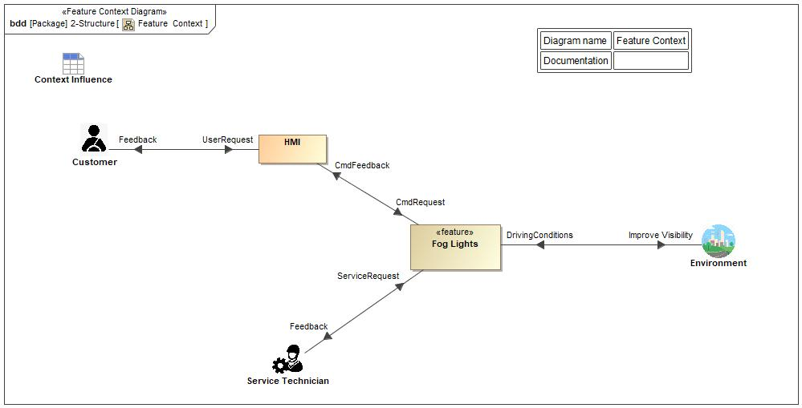

Figure 3: Fog Lights Feature Context Diagram

## List of Influences

|  |  |  |
| --- | --- | --- |
| **ID** | **External Entity** | **Influence Description** |
| UserRequest | Customer To HMI | Based on environmental conditions user requests to activate/deactivate Fog Lights |
| CmdRequest | HMI To Fog Lights | User requests Fog lights to be activated/deactivated via HMI. |
| StatusFeedback | Fog Lights To HMI | Status feedback to HMI |
| DrivingConditions | Environment To Fog Lights | Environment conditions to activate/deactivate Fog Lights |
| Feedback | Fog Lights To Service Technician | Feedback to the Service Technician |
| HMI To Customer | Visual feedback to the customer that Fog Lights are enabled |
| Improve Visibility | Fog Lights To Environment | Main goal of the Feature - improve visibility to driver by Front Fog Lights and to other Drivers from rear of vehicle by Rear Fog Light.. |
| ServiceRequest | Service Technician To Fog Lights | Service technician command |

Table 11: List of Influences for Fog Lights

# Feature Modeling

**#Hint:** Use at least one of the modelling techniques listed in this chapter – and additionally a functional decomposition (refer to chapter 0 “”) – to gather and analyze the feature requirements.

**#Link:** *[Stages- RE Analyze Feature Requirements](https://bd101001.pd2.ford.com/stages/" \l "/workspace/209/_vv/(process/activity/_E_h9QKJNeBGY2aIJCaFfcg))*

## Operation Modes and States

**#Classification:** Optional (Mandatory for Functional Safety)

**#Hint:** Insert (or reference) a description of the feature’s operation modes and states by one or multiple state machine diagrams. The purpose of the state machine is to help analyze the requirements, i.e., if the behavior described in the requirements is consistent and complete. Therefore, the state machine should not provide details, which are not referenced in feature level requirements. It should typically show only those states and transitions, which describe the high level behavior facing or impacting the user.

**#Link:** [Stages - RE Model the States and Modes](https://bd101001.pd2.ford.com/stages/" \l "/workspace/209/_vv/(process/activity/_iKH7oFMNkpOMg85u0m-tig))



Figure 4: Fog Feature Operation Modes and States

|  |  |  |
| --- | --- | --- |
| **State** | **Description** | **Requirements Reference** (optional) |
| Feature Disabled | The Feature is disabled, while the enabling conditions are not met. |  |
| Feature Enabled | The Feature is enabled, while the enabling conditions are met. The Feature can be operated. |  |
| Feature Off | The Feature is in “Off” state and can be turned ON by user request.  behavior :> Rear Fog Light Off |  |
| The Feature is in “Off” state and can be turned ON by user request.  behavior :> Front Fog Light Off |  |
| Feature On | The Feature is in “On” state and can be switched off by user request.  behavior :> Rear Fog Light On |  |
| The Feature is in “On” state and can be switched off by user request.  behavior :> Rear Fog Light On |  |

Table 12: Operation Modes and States

|  |  |  |
| --- | --- | --- |
| **Transition ID** | **Description** | **Requirements Reference**  (optional) |
| T1 | Initialization System Startup | Input conditions dependent on markets |
| T2 | Shut Down |  |
| T3 | User RFL HMI Switch OFF |  |
| T4 | User RFL HMI Switch ON |  |
| T5 | User Front Fog Light HMI OFF |  |
| T6 | User Front Fog Light HMI Switch ON |  |
| T7 | Front Fog Feature Enable Conditions – US. Reference Table 15: Front Fog Light Decision Table | Front Fog enabled when Ignition is in RUN **AND** Front Fog switch is ON **AND** POSITION/PARKING **OR** LOW BEAM **OR** AUTO (with night conditions) **AND** High Beam is OFF. (if Low Beams are ON, then by default POSITOIN/PARKING lamps are ON, also.) |
| T8 | Front Fog Feature Disable Conditions – US. Reference Table 15: Front Fog Light Decision Table | Front Fog is disabled when either Ignition is switched to ACC or OFF **OR** Front Fog switch is deactivated OR Headlight\_Status is OFF **OR** AUTO (with daylight conditions) **OR** High Beam is active. |
| T9 | Rear Fog Feature Enable Conditions | Rear Fog enabled when Ignition is in RUN and Front Fog is ON **OR** Low beam is ON **AND** Rear Fog switch is turned ON |
| T10 | Rear Fog Feature Disable Conditions | Rear Fog disabled when Front Fog is OFF AND Low Beams are OFF OR Rear Fog is turned OFF OR Ignition is (OFF OR ACC) |
| T11 | Front Fog Feature Enable Conditions – EU. Reference Table 15: Front Fog Light Decision Table | Front Fog is enabled when Ignition is in RUN **AND** Front Fog switch is ON **AND** POSITION/PARKING **OR** Low Beams are ON. (High Beam state is a don’t care for EU and if Low Beams are ON, then by default POSITOIN/PARKING lamps are ON, also.) |
| T12 | Front Fog Feature Disable Conditions – EU. Reference Table 15: Front Fog Light Decision Table | Front Fog is disabled when either Ignition is switched to ACC or OFF **OR** Front Fog switch is turned OFF **OR** POSITION/PARKING is OFF **OR** Low Beams are OFF |

Table 13: Transitions between Operational Modes and States

Note: Headlight\_Status is the end state (filtered and debounced) of the MLS switch which encompasses POSITION/PARKLAMPS, OFF, AUTOLAMPS, and HEADLAMPS(LOW BEAM). For convenience, the positions of the MLS are called out as active unless stated otherwise. Example: “POSITION/PARKING” with no further notation, implies POSITON/PARKING is active ON (DEFAULT). Else, “POSITION/PARKING LAMPS are OFF” (STATED OFF CONDITION).







## Use Cases

**#Classification:** Optional (Mandatory for Functional Safety)

**#Hint:** Describe (or reference) the ways the user interacts with the system

**#Link:** [Stages - RE Model a Use Case](https://bd101001.pd2.ford.com/stages/#/workspace/209/_vv/(process/activity/_A8UUYPnykpCMg85u0m-tig))

### Use Case Diagram

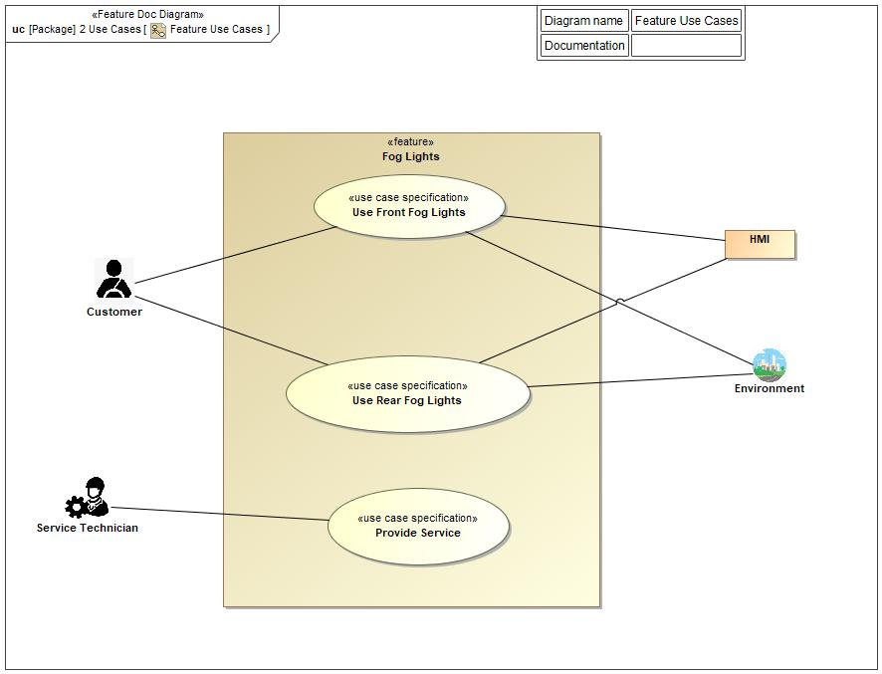

Figure 5: Use Case Diagram

### Actors

| Actor | Description |
| --- | --- |
| Driver | Human Driver (operator) of the vehicle. |
| Environment | The physical space where the vehicle is. -> As an example: on the road at Nighttime or on the road during fog, rain, snow, etc. |
| HMI | Interface between customer and the feature |
| Service Technician | Operator that performs feature's service/maintenance |

Table 14: List of Actors

#### Use Case Descriptions

###UC\_FNC\_ Fog Light\_00004### Initiate Front Fog – US Market

|  |  |  |
| --- | --- | --- |
| **Purpose** |  | Turn on Front Fog Lamps |
| **Actors** |  | Driver |
| **Precondition** |  | Front Fog Light installed |
|  |  | Front Fog Light is OFF |
|  |  | Ignition is OFF |
| **Main Flow** | M1 | Front Fog enabled when Ignition is in RUN **AND** Front Fog switch is ON **AND** POSITION/PARKING **OR** LOW BEAM **OR** AUTO (with night conditions) and High Beam is OFF. |
| **Post-condition** |  | Exterior Front Fog Lamps turn ON and Front Fog Telltale light is ON |

###UC\_FNC\_ Fog Light\_00005### Initiate Front Fog – EU Market

|  |  |  |
| --- | --- | --- |
| **Purpose** |  | Turn on Front Fog Lamps |
| **Actors** |  | Driver |
| **Precondition** |  | Front Fog Light installed |
|  |  | Front Fog Light is OFF |
|  |  | Ignition is OFF |
| **Main Flow** | M1 | Front Fog enabled when Ignition is in RUN **AND** Front Fog switch is ON **AND** POSITION/PARKING **OR** Low Beams are ON. |
| **Post-condition** |  | Exterior Front Fog Lamps turn ON and Front Fog Telltale light is ON |

###UC\_FNC\_ Fog Light\_00006### Initiate Rear Fog

|  |  |  |
| --- | --- | --- |
| **Purpose** |  | Turn ON Rear Fog Lamps |
| **Actors** |  | Driver |
| **Precondition** |  | Rear Fog Light installed |
|  |  | Rear Fog Light is OFF |
|  |  | Ignition is OFF |
| **Main Flow 1** | M1 | Driver initiates ignition RUN |
|  | M2 | Front Fog Lamps are ON **OR** Low Beams are ON. |
|  | M3 | Driver requests Rear Fog Lamps ON |
| **Post-condition** |  | Exterior Rear Fog Lamps turn ON and Rear Fog Telltale light is ON |

###UC\_FNC\_ Fog Light\_00007### Deactivate Front Fog – US Market

|  |  |  |
| --- | --- | --- |
| **Purpose** |  | Turn OFF Front Fog Lights |
| **Actors** |  | Driver |
| **Precondition** |  | Front Fog Lights are ON |
|  |  | Ignition is ON |
| **Main Flow** | M1 | Front Fog is disabled when either Ignition is switched to ACC or OFF **OR** Front Fog switch is deactivated OR Headlight\_Status is OFF **OR** AUTO (with daylight conditions) **OR** High Beam is active. |
| **Post-condition** |  | Exterior Front Fog Lights are turned OFF and Front Fog Telltale turns OFF |

###UC\_FNC\_ Fog Light\_00008### Deactivate Front Fog – EU Market

|  |  |  |
| --- | --- | --- |
| **Purpose** |  | Turn OFF Front Fog Lights |
| **Actors** |  | Driver |
| **Precondition** |  | Front Fog Lights are ON |
|  |  | Ignition is ON |
| **Main Flow** | M1 | Front Fog is OFF when either Ignition is switched to ACC or OFF **OR** Front Fog switch is turned OFF **OR** POSITION/PARKING is OFF **OR** Low Beams are OFF |
| **Post-condition** |  | Exterior Front Fog Lights are turned OFF and Front Fog Telltale turns OFF |

###UC\_FNC\_ Fog Light\_00009### Deactivate Rear Fog

|  |  |  |
| --- | --- | --- |
| **Purpose** |  | Turn OFF Rear Fog Lights |
| **Actors** |  | Driver |
| **Precondition** |  | Rear Fog Light is ON |
|  |  | Ignition is ON |
| **Main Flow** | M1 | Driver requests ignition OFF or ACC |
|  | M2 | **OR** Rear Fog OFF |
|  | M3 | **OR** Front Fog is OFF **AND** Low Beams are OFF |
| **Post-condition** |  | Exterior Rear Fog Lights are turned OFF and Rear Fog Telltale turns OFF |















































## Driving and Operation Scenarios

**#Classification:** Optional (Mandatory for Functional Safety)

**#Hint:** “Driving Scenario” is a story-board like technique, which focusses on the feature interacting with its environment.

**#Functional Safety**: Describe (or reference) driving and operating scenarios that impact the functionality of the item/feature, including potential operational and environmental constraints. The objective of this section is to describe the environment of the feature in order to understand its impact on the feature. Concept FMEA and P-diagram may be an input for this section.

**#Macro:** [Add Ins -> Add Requirement macro](http://wiki.ford.com/display/RequirementsEngineering/How+to+use+the+Specification+Templates" \l "HowtousetheSpecificationTemplates-AddNewRequirement) (select “Scenario” as type)

**#Link:** [Stages - RE Model a Driving Situation](https://bd101001.pd2.ford.com/stages/" \l "/workspace/209/_vv/(process/activity/_KC_OMN4hkpGMg85u0m-tig))







## Decision Tables

|  |  |  |  |  |
| --- | --- | --- | --- | --- |
| States | Ignition State  (OFF, ACC, RUN) | Front Fog Light HMI  (ON, OFF) | Lamp HMI status  (Off, Position, Low Beam, Auto) | Output – Front Fog Light (ON, OFF) |
| 1 | OFF | Don’t care | Don’t care | OFF |
| 2 | ACC | Don’t care | Don’t care | OFF |
| 3 | RUN | ON | OFF | OFF |
| 4 | RUN | ON | Position | ON |
| 5 | RUN | ON | Low Beam (US) | ON |
| 6 | RUN | ON | Low Beam **OR** High Beam (EU) | ON |
| 7 | RUN | ON | Auto Light DAY | OFF |
| 8 | RUN | ON | Auto Light NIGHT | ON |
| 9 | RUN | OFF | Don’t care | OFF |



Table 15: Front Fog Light Decision Table

|  |  |  |  |  |  |
| --- | --- | --- | --- | --- | --- |
| States | Ignition State  (OFF, ACC, RUN) | Front Fog Light HMI (ON, OFF) | Rear Fog Light HMI (ON, OFF) | Lamp HMI status  (Off, Position, Low Beam, Auto) | Output – Rear Fog Light  (ON, OFF) |
| 1 | OFF | Don’t care | Don’t care | Don’t care | OFF |
| 2 | ACC | Don’t care | Don’t care | Don’t care | OFF |
| 3 | RUN | ON | ON | OFF | OFF |
| 4 | RUN | ON | ON | Low Beam | ON |
| 5 | RUN | OFF | Don’t care | Don’t care | OFF |

Table 16: Rear Fog Light Decision Table

# Feature Requirements

## Front Fog Functional Requirements

###R\_FNC\_ Configurations\_0001### Front Fog Auto Cancel

**FrontFog\_AutoCancel\_Cfg** shall be set to NO\_CANCEL for US/Canada and set to CANCEL for all other markets.

|  |  |  |  |  |  |  |  |
| --- | --- | --- | --- | --- | --- | --- | --- |
| Requirement ID: ###R\_FNC\_ Configurations\_00068### | | | | | | | |
| **Rationale** |  | | | | | | | |
| **Acceptance Criteria** |  | | | | | | | |
| **Notes** |  | | | | | | | |
| **Source** | ECE R48 6.11.7.3.1 | | | | | **Owner** | PD and ASO | |
| **Source Req.** | See requirements in section 2.3 | | | | | **V&V Method** | System level, Bread Board, HIL | |
| **Type** | Functional | | | **Priority** | High (Mandatory) | **Status** | Approved | |
| [Req. Template](http://wiki.ford.com/display/RequirementsEngineering/Requirements+Attributes) Version | | 6.1b | End of Requirement | | | | |

###R\_FNC\_ Configurations\_0002### Front Fog with High Beams Configuration

**FrontFog\_WithHighBeams\_Cfg** shall be set to INHIBIT for US and CANADA and ALLOW for all other markets.

|  |  |  |  |  |  |  |  |
| --- | --- | --- | --- | --- | --- | --- | --- |
| Requirement ID: ###R\_FNC\_ Configurations\_00069### | | | | | | | |
| **Rationale** | Some US States require the foglamps turn off when the high beams are activated. | | | | | | | |
| **Acceptance Criteria** |  | | | | | | | |
| **Notes** |  | | | | | | | |
| **Source** | See requirements in section 2.3 | | | | | **Owner** | PD and ASO | |
| **Source Req.** | NA | | | | | **V&V Method** | System level, Bread Board, HIL | |
| **Type** | Functional | | | **Priority** | High (Mandatory) | **Status** | Approved | |
| [Req. Template](http://wiki.ford.com/display/RequirementsEngineering/Requirements+Attributes) Version | | 6.1b | End of Requirement | | | | |

###R\_FNC\_ Front Fog Light\_0003### Front Fog Light enabling condition - US

**US** Market - Front Fog enabled when Ignition is in RUN **AND** Front Fog switch is ON **AND** POSITION/PARKING **OR** LOW BEAM **OR** AUTO (with night conditions) and High Beam is OFF.

|  |  |  |  |  |  |  |  |
| --- | --- | --- | --- | --- | --- | --- | --- |
| Requirement ID: ###R\_FNC\_ Front Fog Light\_00060### | | | | | | | |
| **Rationale** |  | | | | | | | |
| **Acceptance Criteria** |  | | | | | | | |
| **Notes** |  | | | | | | | |
| **Source** | SAE J583 | | | | | **Owner** | PD and ASO | |
| **Source Req.** | See requirements in section 2.3 | | | | | **V&V Method** | System level, Bread Board, HIL | |
| **Type** | Functional | | | **Priority** | High (Mandatory) | **Status** | Approved | |
| [Req. Template](http://wiki.ford.com/display/RequirementsEngineering/Requirements+Attributes) Version | | 6.1b | End of Requirement | | | | |

###R\_FNC\_ Front Fog Light\_0004### Front Fog Light enabling condition - EU

**EU** Market - Front Fog Lamps shall be enabled when Ignition is in RUN **AND** Front Fog switch is ON **AND** POSITION/PARKING (Parking Lamps are ON when Position is ON) **OR** Low Beams are ON.

|  |  |  |  |  |  |  |  |
| --- | --- | --- | --- | --- | --- | --- | --- |
| Requirement ID: ###R\_FNC\_ Front Fog Light\_00062### | | | | | | | |
| **Rationale** |  | | | | | | | |
| **Acceptance Criteria** |  | | | | | | | |
| **Notes** |  | | | | | | | |
| **Source** | ECE R48 6.3.7 | | | | | **Owner** | PD and ASO | |
| **Source Req.** | See requirements in section 2.3 | | | | | **V&V Method** | System level, Bread Board, HIL | |
| **Type** | Functional | | | **Priority** | High (Mandatory) | **Status** | Approved | |
| [Req. Template](http://wiki.ford.com/display/RequirementsEngineering/Requirements+Attributes) Version | | 6.1b | End of Requirement | | | | |

###R\_FNC\_ Front Fog Light\_0005### Front Fog Light disabling conditions - US

**US** Market - Front Fog is disabled when either Ignition is switched to ACC or OFF **OR** Front Fog switch is turned OFF **OR** Headlight\_Status is OFF **OR** AUTO (with daylight conditions) **OR** High Beam is active.

|  |  |  |  |  |  |  |  |
| --- | --- | --- | --- | --- | --- | --- | --- |
| Requirement ID: ###R\_FNC\_ Front Fog Light\_00064### | | | | | | | |
| **Rationale** |  | | | | | | | |
| **Acceptance Criteria** |  | | | | | | | |
| **Notes** |  | | | | | | | |
| **Source** | SAE J583 | | | | | **Owner** | PD and ASO | |
| **Source Req.** | See requirements in section 2.3 | | | | | **V&V Method** | System level, Bread Board, HIL | |
| **Type** | Functional | | | **Priority** | High (Mandatory) | **Status** | Approved | |
| [Req. Template](http://wiki.ford.com/display/RequirementsEngineering/Requirements+Attributes) Version | | 6.1b | End of Requirement | | | | |

###R\_FNC\_ Front Fog Light\_0006### Front Fog Light disabling conditions - NA

**EU** Market - Front Fog is OFF when either Ignition is switched to ACC or OFF **OR** Front Fog switch is turned OFF **OR** POSITION/PARKING is OFF **OR** Low Beams are OFF.

|  |  |  |  |  |  |  |  |
| --- | --- | --- | --- | --- | --- | --- | --- |
| Requirement ID: ###R\_FNC\_ Front Fog Light\_00066### | | | | | | | |
| **Rationale** |  | | | | | | | |
| **Acceptance Criteria** |  | | | | | | | |
| **Notes** |  | | | | | | | |
| **Source** | ECE R48 6.3.7 | | | | | **Owner** | PD and ASO | |
| **Source Req.** | See requirements in section 2.3 | | | | | **V&V Method** | System level, Bread Board, HIL | |
| **Type** | Functional | | | **Priority** | High (Mandatory) | **Status** | Approved | |
| [Req. Template](http://wiki.ford.com/display/RequirementsEngineering/Requirements+Attributes) Version | | 6.1b | End of Requirement | | | | |

###R\_F\_Front Fog Telltale Display\_0007### Telltale Display

The Front Fog Telltale indicator, when illuminated, shall be easily visible and recognizable to the vehicle operator during the operation of the vehicle.

|  |  |  |  |  |  |  |  |
| --- | --- | --- | --- | --- | --- | --- | --- |
| Requirement ID: ###R\_F\_Front Fog Telltale Display\_00055### | | | | | | | |
| **Rationale** | To follow the standard icon and imagery for displaying the telltale for front fog lamps. | | | | | | | |
| **Acceptance Criteria** |  | | | | | | | |
| **Notes** |  | | | | | | | |
| **Source** | ECE R121; SAE J583; F/CMVSS 101 | | | | | **Owner** | PD and ASO | |
| **Source Req.** | See requirements in section 2.3 | | | | | **V&V Method** | System level, Bread Board, HIL | |
| **Type** | Functional | | | **Priority** | High (Mandatory) | **Status** | Approved | |
| [Req. Template](http://wiki.ford.com/display/RequirementsEngineering/Requirements+Attributes) Version | | 6.1b | End of Requirement | | | | |

###R\_F\_Front Telltale Illumination visible \_0008### Telltale Illumination

An indicator front fog telltale shall be illuminated whenever the front fog lamps are illuminated.

|  |  |  |  |  |  |  |  |
| --- | --- | --- | --- | --- | --- | --- | --- |
| Requirement ID: ###R\_F\_Telltale Illumination \_00040### | | | | | | | |
| **Rationale** | To let the driver know that their front fog lamps are activated. | | | | | | | |
| **Acceptance Criteria** |  | | | | | | | |
| **Notes** |  | | | | | | | |
| **Source** | ECE R48 6.3.8 ; SAE J583; F/CMVSS 101 | | | | | **Owner** | PD and ASO | |
| **Source Req.** | See requirements in section 2.3 | | | | | **V&V Method** | System level, Bread Board, HIL | |
| **Type** | Interface | | | **Priority** | High (Mandatory) | **Status** | Approved | |
| [Req. Template](http://wiki.ford.com/display/RequirementsEngineering/Requirements+Attributes) Version | | 6.1b | End of Requirement | | | | |

###R\_F\_Front Fog Snow Plow Mode\_0009### Snow Plow Mode

The Front Fog Light feature shall be disabled if Snow Plow Mode is "ENABLED".

|  |  |  |  |  |  |  |  |
| --- | --- | --- | --- | --- | --- | --- | --- |
| Requirement ID: ###R\_F\_Front Fog Snow Plow Mode\_00011### | | | | | | | |
| **Rationale** | To prevent the front fog lamp light from reflecting off the snow plow and glaring the driver. | | | | | | | |
| **Acceptance Criteria** |  | | | | | | | |
| **Notes** |  | | | | | | | |
| **Source** | NA | | | | | **Owner** | PD | |
| **Source Req.** | NA | | | | | **V&V Method** | System level, Bread Board, HIL | |
| **Type** | Functional | | | **Priority** | Medium (Highly Recommended) | **Status** | Approved | |
| [Req. Template](http://wiki.ford.com/display/RequirementsEngineering/Requirements+Attributes) Version | | 6.1b | End of Requirement | | | | |















## Rear Fog Functional Requirements

###R\_F\_Rear Fog Telltale Display\_0010### Telltale Display

The Rear Fog Telltale indicator shall be illuminated whenever the rear fog lamps are activated and shall be easily visible and recognizable to the vehicle operator during the operation of the vehicle.

|  |  |  |  |  |  |  |  |
| --- | --- | --- | --- | --- | --- | --- | --- |
| Requirement ID: ###R\_F\_Rear Fog Telltale Display\_00056### | | | | | | | |
| **Rationale** | To inform the driver that the rear fog lamps are on. | | | | | | | |
| **Acceptance Criteria** |  | | | | | | | |
| **Notes** |  | | | | | | | |
| **Source** | ECE R48 6.11.8 ;ECE R121 | | | | | **Owner** | PD and ASO | |
| **Source Req.** | See requirements in section 2.3 | | | | | **V&V Method** | System level, Bread Board, HIL | |
| **Type** | Functional | | | **Priority** | High (Mandatory) | **Status** | Approved | |
| [Req. Template](http://wiki.ford.com/display/RequirementsEngineering/Requirements+Attributes) Version | | 6.1b | End of Requirement | | | | |

###R\_F\_Rear Fog Light enabling condition \_0011### Rear Fog Light enabling condition

The Rear Fog Light(s) shall turn ON when Ignition is in RUN and Front Fog is ON **OR** Low beam is ON **AND** Rear Fog switch is turned ON

|  |  |  |  |  |  |  |  |
| --- | --- | --- | --- | --- | --- | --- | --- |
| Requirement ID: ###R\_F\_Rear Fog Lighting Switch select/deselect\_00029### | | | | | | | |
| **Rationale** | Front fog lamps must be ON for the rear foglamps to be enabled. If vehicle is not equipped with front fog lamps then the low beams need to be ON for the rear foglamps to be enabled. | | | | | | | |
| **Acceptance Criteria** |  | | | | | | | |
| **Notes** |  | | | | | | | |
| **Source** | ECE R48 6.11.7 | | | | | **Owner** | PD and ASO | |
| **Source Req.** | See requirements in section 2.3 | | | | | **V&V Method** | System level, Bread Board, HIL | |
| **Type** | Functional | | | **Priority** | High (Mandatory) | **Status** | Approved | |
| [Req. Template](http://wiki.ford.com/display/RequirementsEngineering/Requirements+Attributes) Version | | 6.1b | End of Requirement | | | | |

###R\_F\_Rear Fog Lighting deselect\_0012### Rear Fog Light deactivation

Rear Fog Light(s) shall be turned off when Front Fog is OFF **OR** Low Beams are OFF **OR** Rear Fog is turned OFF **OR** Ignition is (OFF OR ACC)

|  |  |  |  |  |  |  |  |
| --- | --- | --- | --- | --- | --- | --- | --- |
| Requirement ID: ###R\_F\_Rear Fog Lighting Switch Status on CAN\_00031### | | | | | | | |
| **Rationale** |  | | | | | | | |
| **Acceptance Criteria** |  | | | | | | | |
| **Notes** |  | | | | | | | |
| **Source** | ECE R48 6.11.7 | | | | | **Owner** | PD and ASO | |
| **Source Req.** | See requirements in section 2.3 | | | | | **V&V Method** | System level, Bread Board, HIL | |
| **Type** | Functional | | | **Priority** | High (Mandatory) | **Status** | Approved | |
| [Req. Template](http://wiki.ford.com/display/RequirementsEngineering/Requirements+Attributes) Version | | 6.1b | End of Requirement | | | | |











###R\_F\_RFL with Trailer\_00013### Rear Fog Lights with Trailer

Rear Fog Light(s) shall be configurable, if in case a Trailer is attached to the vehicle, to have both RFL's (Trailer and Vehicle) activated or only the Trailers RFL activated.

|  |  |  |  |  |  |  |  |
| --- | --- | --- | --- | --- | --- | --- | --- |
| Requirement ID: ###R\_F\_RFL with Trailer\_00019### | | | | | | | |
| **Rationale** | To provide flexibility of behavior when a trailer is attached for different market requirements (if needed) | | | | | | | |
| **Acceptance Criteria** |  | | | | | | | |
| **Notes** |  | | | | | | | |
| **Source** | ECE R48 6.11.7.5 | | | | | **Owner** | PD and ASO | |
| **Source Req.** | See requirements in section 2.3 | | | | | **V&V Method** | System level, Bread Board, HIL | |
| **Type** | Functional | | | **Priority** | High (Mandatory) | **Status** | Approved | |
| [Req. Template](http://wiki.ford.com/display/RequirementsEngineering/Requirements+Attributes) Version | | 6.1b | End of Requirement | | | | |



## Non-Functional Requirements

***#Hint:*** *Non-functional requirements specify quality attributes in addition to the pure functional behavior given by the functional requirements. Examples for quality attributes: Performance (e.g. data throughput), timing (if not already included in the functional requirements), security (e.g. how secure does an algorithm have to be), reliability (e.g. mean time between failure) or maintainability.*

### Safety

**#Classification:** Optional (Remove, if not used)

**#Functional Safety:** Only those safety requirements, which are not related to Functional Safety (ISO26262) should go here. For Functional Safety refer to chapter 6 “Functional Safety”.

### Security

**#Classification:** Optional (Remove, if not used)

**#Cybersecurity:** Only those security requirements, which are not related to the Cybersecurity (ISO21434) should go here. For Cybersecurity requirements refer to chapter 7 “Cybersecurity”.

### Reliability

**#Classification:** Optional (Remove, if not used)



## HMI Requirements



###R\_F\_Front Fog Light switch HMI\_0014### HMI Switch Operation

(Variant 1) Front Fog Lighting Switch activation shall toggle the user request for Front Fog Lamps. Pressing the switch turns the Front Fog Lamps on. Releasing the switch leaves them on. Pressing the switch again turns them off. Releasing the switch leaves them off.

|  |  |  |  |  |  |  |  |
| --- | --- | --- | --- | --- | --- | --- | --- |
| Requirement ID: ###R\_F\_Front Fog Light switch HMI\_00027### | | | | | | | |
| **Rationale** | This is for physical switch design. | | | | | | | |
| **Acceptance Criteria** |  | | | | | | | |
| **Notes** |  | | | | | | | |
| **Source** | NA | | | | | **Owner** | ASO and PD. | |
| **Source Req.** | NA | | | | | **V&V Method** | System level, Bread Board, HIL | |
| **Type** | Interface | | | **Priority** | Medium (Highly Recommended) | **Status** | Approved | |
| [Req. Template](http://wiki.ford.com/display/RequirementsEngineering/Requirements+Attributes) Version | | 6.1b | End of Requirement | | | | |

###R\_F\_Front Fog Light Switch HMI operation\_0015### HMI Soft Button Operation Behavior

(Variant 2) Front Fog Lighting shall be activated via touch screen interface (soft button). Pressing the screen button turns the Front Fog Lamps on. Releasing the screen button leaves them on. Pressing the screen button again turns them off. Releasing the screen button leaves them off.

|  |  |  |  |  |  |  |  |
| --- | --- | --- | --- | --- | --- | --- | --- |
| Requirement ID: ###R\_F\_Rear Fog Light Switch HMI operation\_00058### | | | | | | | |
| **Rationale** | To support reductive switch design | | | | | | | |
| **Acceptance Criteria** |  | | | | | | | |
| **Notes** |  | | | | | | | |
| **Source** | NA | | | | | **Owner** | ASO and PD. | |
| **Source Req.** | NA | | | | | **V&V Method** | System level, Bread Board, HIL | |
| **Type** | Interface | | | **Priority** | Medium (Highly Recommended) | **Status** | Approved | |
| [Req. Template](http://wiki.ford.com/display/RequirementsEngineering/Requirements+Attributes) Version | | 6.1b | End of Requirement | | | | |

###R\_F\_Front Fog Light switch HMI\_0016### HMI Switch

The Front Fog Feature shall have an HMI method to activate and deactivate the Front Fog Feature.

|  |  |  |  |  |  |  |  |
| --- | --- | --- | --- | --- | --- | --- | --- |
| Requirement ID: ###R\_F\_Front Fog Light switch HMI\_00022### | | | | | | | |
| **Rationale** | Must have a method of activation and deactivation | | | | | | | |
| **Acceptance Criteria** |  | | | | | | | |
| **Notes** | Conform to the latest regulations. | | | | | | | |
| **Source** | See requirements in section 2.3 | | | | | **Owner** | ASO and PD. | |
| **Source Req.** | NA | | | | | **V&V Method** | System level, Bread Board, HIL | |
| **Type** | Interface | | | **Priority** | High (Mandatory) | **Status** | Approved | |
| [Req. Template](http://wiki.ford.com/display/RequirementsEngineering/Requirements+Attributes) Version | | 6.1b | End of Requirement | | | | |



###R\_F\_Front Fog Light Telltale\_0017### HMI Telltale

The Fog Light Feature shall have a visible telltale feedback indicator observable to the driver when Front Fog Light Feature is active.

|  |  |  |  |  |  |  |  |
| --- | --- | --- | --- | --- | --- | --- | --- |
| Requirement ID: ###R\_F\_Front Fog Light Telltale\_00021### | | | | | | | |
| **Rationale** | To inform the driver that the lamps are on. | | | | | | | |
| **Acceptance Criteria** |  | | | | | | | |
| **Notes** |  | | | | | | | |
| **Source** | ECE R121, SAE J583 | | | | | **Owner** | ASO and PD. | |
| **Source Req.** | See requirements section 2.3 | | | | | **V&V Method** | System level, Bread Board, HIL | |
| **Type** | Interface | | | **Priority** | High (Mandatory) | **Status** | Approved | |
| [Req. Template](http://wiki.ford.com/display/RequirementsEngineering/Requirements+Attributes) Version | | 6.1b | End of Requirement | | | | |

###R\_F\_Rear Fog Light Telltale HMI\_0018### HMI Telltale

The Rear Fog Light Feature shall have a visible telltale feedback indicator observable to the driver when Rear Fog Light Feature is active.

|  |  |  |  |  |  |  |  |
| --- | --- | --- | --- | --- | --- | --- | --- |
| Requirement ID: ###R\_F\_Rear Fog Light Telltale HMI\_00023### | | | | | | | |
| **Rationale** | To inform the driver that the lamps are on. | | | | | | | |
| **Acceptance Criteria** |  | | | | | | | |
| **Notes** |  | | | | | | | |
| **Source** | ECE R48 6.11.8 ;ECE R121 | | | | | **Owner** | ASO and PD. | |
| **Source Req.** | Compliance with ECE R121  Compliance with ECE R48 | | | | | **V&V Method** | System level, Bread Board, HIL | |
| **Type** | Interface | | | **Priority** | High (Mandatory) | **Status** | Approved | |
| [Req. Template](http://wiki.ford.com/display/RequirementsEngineering/Requirements+Attributes) Version | | 6.1b | End of Requirement | | | | |



###R\_F\_Rear Fog Light Switch HMI\_0019### HMI Switch

The Rear Fog Feature shall have an HMI method to activate and deactivate the Rear Fog Light Feature.

|  |  |  |  |  |  |  |  |
| --- | --- | --- | --- | --- | --- | --- | --- |
| Requirement ID: ###R\_F\_Rear Fog Light Switch HMI\_00024### | | | | | | | |
| **Rationale** | Must have a method of activation and deactivation. | | | | | | | |
| **Acceptance Criteria** |  | | | | | | | |
| **Notes** |  | | | | | | | |
| **Source** | ECE R48 6.7.11; SAE J583 | | | | | **Owner** | PD and ASO | |
| **Source Req.** | See requirements in section 2.3 | | | | | **V&V Method** | System level, Bread Board, HIL | |
| **Type** | Interface | | | **Priority** | High (Mandatory) | **Status** | Approved | |
| [Req. Template](http://wiki.ford.com/display/RequirementsEngineering/Requirements+Attributes) Version | | 6.1b | End of Requirement | | | | |

###R\_F\_Rear Fog Light Switch HMI operation\_0020### HMI Switch Operation

(Variant 1) Rear Fog Lighting Switch activation shall toggle the user request for Rear Fog Lamps. Pressing the switch turns the Rear Fog Lamps on. Releasing the switch leaves them on. Pressing the switch again turns them off. Releasing the switch leaves them off.

|  |  |  |  |  |  |  |  |
| --- | --- | --- | --- | --- | --- | --- | --- |
| Requirement ID: ###R\_F\_Rear Fog Light Switch HMI operation\_00059### | | | | | | | |
| **Rationale** | This is for a physical switch design. | | | | | | | |
| **Acceptance Criteria** |  | | | | | | | |
| **Notes** |  | | | | | | | |
| **Source** | NA | | | | | **Owner** | PD and ASO | |
| **Source Req.** | NA | | | | | **V&V Method** | System level, Bread Board, HIL | |
| **Type** | Interface | | | **Priority** | Medium (Highly Recommended) | **Status** | Approved | |
| [Req. Template](http://wiki.ford.com/display/RequirementsEngineering/Requirements+Attributes) Version | | 6.1b | End of Requirement | | | | |

###R\_F\_Rear Fog Light Switch HMI operation\_0021### HMI Soft Button Operation Behavior

(Variant 2) Rear Fog Lighting shall be activated via touch screen interface (soft button). Pressing the screen button turns the Rear Fog Lamps on. Releasing the screen button leaves them on. Pressing the screen button again turns them off. Releasing the screen button leaves them off.

|  |  |  |  |  |  |  |  |
| --- | --- | --- | --- | --- | --- | --- | --- |
| Requirement ID: ###R\_F\_Rear Fog Light Switch HMI operation\_00057### | | | | | | | |
| **Rationale** | This is to support reductive switch design. | | | | | | | |
| **Acceptance Criteria** |  | | | | | | | |
| **Notes** |  | | | | | | | |
| **Source** | NA | | | | | **Owner** | PD and ASO | |
| **Source Req.** | NA | | | | | **V&V Method** | System level, Bread Board, HIL | |
| **Type** | Interface | | | **Priority** | Medium (Highly Recommended) | **Status** | Approved | |
| [Req. Template](http://wiki.ford.com/display/RequirementsEngineering/Requirements+Attributes) Version | | 6.1b | End of Requirement | | | | |



## Other Requirements

### Design Requirements

### Manufacturing Requirements

### Service Requirements



#### Cloud Connectivity Data Analytics Requirements

### After Sales Requirements

### Process requirements

# Functional Safety

## System Behaviors for HARA

Reference HARA documents:

* **VDOC083772** for Front Fog

|  |  |  |
| --- | --- | --- |
| ID | Name | Description |
| **F\_01\_01:** | Activate Front Fog Lamps | Front Fog Lamps do not get activated |
| **F\_02\_01** | Deactivate Front Fog Lamps | Front Fog Lamps do not get deactivated |
| **F\_01\_02** | Activate Front Fog Lamps | Front Fog Lamps get activated without request |
| **F\_02\_02** | Deactivate Front Fog Lamps | Front Fog Lamps get deactivated without request |
| **F\_01\_03** | Activate Front Fog Lamps | Front Fog Lamps get activated with more light output. |

Table 17: System Behaviors for HARA

* **VDOC077104** for Rear Fog

|  |  |  |
| --- | --- | --- |
| ID | Name | Description |
| **F\_01\_01:** | Activate Rear Fog Lamps | Rear Fog Lamps do not get activated |
| **F\_02\_01** | Deactivate Rear Fog Lamps | Rear Fog Lamps do not get deactivated |
| **F\_01\_02** | Activate Rear Fog Lamps | Rear Fog Lamps get activated without request |
| **F\_02\_02** | Deactivate Rear Fog Lamps | Rear Fog Lamps get deactivated without request |
| **F\_01\_03** | Activate Rear Fog Lamps | Rear Fog Lamps get activated with more light output. |
| **F\_01\_04** | Activate Rear Fog Lamps | Rear Fog Lamps get activated with less light output. |

Table 18: System Behaviors for HARA

## Functional Safety Assumptions

|  |  |  |  |  |
| --- | --- | --- | --- | --- |
| ID | | Assumption | | |
| **A1.1** | **Name** | | Front Fog Lamp Intended Function | |
| **Description** | | Front fog lamps are supposed to be switched on instead of low beam in foggy conditions with a seeing distance below 50m. (Position Light + Front Fog Lamp) | |
| **Purpose** | | Reduce glare for the driver caused by the own low beam. | |
| **Category** | | Vehicle | |
| **Related Requirements IDs** | |  | |
| **A2.1** | **Name** | | Front Fog Lamp activation | |
| **Description** | | Fr Front fog lamps can be switched on with light switch in position 1 (position light) or in position 2 (low beam). Driving with Fog Lamps and Low Beam on does not cause a hazard and is not considered in this HARA. | |
| **Purpose** | |  | |
| **Category** | | Behavioral | |
| **Related Requirements IDs** | |  | |

Table 19: Functional Safety Assumptions for FRONT FOG

|  |  |  |  |
| --- | --- | --- | --- |
| ID | | Assumption | |
| **A1.1** | **Name** | | Rear Fog Lamp Intended Function |
| **Description** | | Driver is driving in foggy conditions. Driver engages rear fog lamps by pressing rear foglamp switch. Rear fog lamps are active. |
| **Purpose** | | Better visibility of your vehicle for others while driving in foggy conditions with limited visibility |
| **Category** | | Vehicle |
| **Related Requirements IDs** | |  |
| **A1.2** | **Name** | | All other Rear Lamps are fully operational |
| **Description** | | Driver is driving in foggy conditions. Driver engages rear fog lamps by pressing Stop, Position, Turn and the reflex properties of the lamp assembly are fully operational |
| **Purpose** | | Always provides a level of visibility to other traffic participants. |
| **Category** | | Vehicle |
| **Related Requirements IDs** | |  |
| **A2.1** | **Name** | | Rear Fog Lamp activation |
| **Description** | | Rear fog lamps can be switched on with light switch in position 1 (position light) and front fog lamps activated or in position 2 (low beam). Rear Fog Lamps should only be used in highly restricted visibility. Driving with Rear Fog Lamps and Low beam or front fog lamps and position lights is not considered in this HARA |
| **Purpose** | |  |
| **Category** | | Behavioral |
| **Related Requirements IDs** | |  |

Table 20: Functional Safety Assumptions for REAR FOG

## Safety Goals

*ASIL rated QM – No Safety Goals*



## Functional Safety Requirements

*ASIL rated QM – No FSR’s*

### Derivation of Functional Safety Requirements on Assumptions

*ASIL rated QM – No FSR’s*

### ASIL Decomposition of Functional Safety Requirements



*ASIL rated QM – No FSR’s*

# Cybersecurity

**#Classification**: Cybersecurity only – leave a statement “Not Applicable” otherwise and remove subchapters.









# Architecture

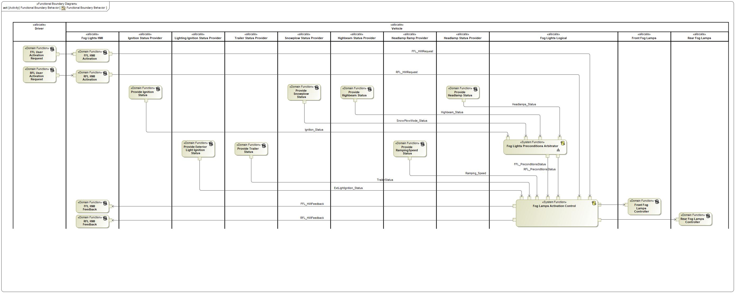

Figure 6: Functional Boundary Behavior

### Functions

**#Hint:** The functions derived by functional decomposition should be listed and described in the table below

| **Function Name** | Description | Comments |
| --- | --- | --- |
| *(activity)* Provide Exterior Light Ignition Status | *(activity)* This function provides information about the state of the Lighting Ignition in order to avoid light flicker during vehicle's engine start. |  |
| *(activity)* Provide Trailer Status | *(activity)* This function provides information about presence of a trailer connected to the vehicle in order to determine the Rear Fog Lights function. |  |
| *(activity)* Provide RampingSpeed Status | *(activity)* This function provides information about on/off delay to turn on/off the Front Fog Lamps. Possible values are: IMMEDIATELY, FAST, SLOW or MEDIUM. |  |
| *(activity)* Fog Lights Preconditions Arbitrator | *(activity)* This function determines if preconditions for Front and Rear Fog Lights are met. Possible values are: TRUE or FALSE. |  |
| *(activity)* Provide Highbeam Status | *(activity)* This function provides information about the state of the Highbeam. Possible values are: ON or OFF. |  |
| *(activity)* Provide Snowplow Status | *(activity)* This function provides information about the state of the Snowplow feature. Possible values are: ENABLED or DISABLED. |  |
| *(activity)* Rear Fog Lamps Controller | *(activity)* This function enable the Rear Fog Lamps to be activated or deactivated. |  |
| *(activity)* FFL HMI Activation | *(activity)* This function process the user command over the Front Fog Lights HMI, |  |
| *(activity)* RFL HMI Feedback | *(activity)* This function process the user visual feedback once Rear Fog Lamps were actuated (on or off). |  |
| *(activity)* Provide Ignition Status | *(activity)* This function provides information about the state of the vehicle's engine. Possible values are: OFF, ACC, START or RUN. |  |
| *(activity)* Fog Lamps Activation Control | *(activity)* This function determines when the Fog Lights (Front or Rear) must be turned on/off in function of preconditions and user request. |  |
| *(activity)* RFL User Activation Request | *(activity)* This function represents the user action over the Rear Fog Lights HMI. |  |
| *(activity)* Provide Headlamp Status | *(activity)* This function provides information about the status of the headlamps HMI. Possible values are: OFF, PARKING/POSITION, HEADLAMPS or AUTOLAMPS. |  |
| *(activity)* FFL HMI Feedback | *(activity)* This function process the user visual feedback once Front Fog Lamps were actuated (on or off). |  |
| *(activity)* FFL User Activation Request | *(activity)* This function represents the user action over the Front Fog Lights HMI. |  |
| *(activity)* Front Fog Lamps Controller | *(activity)* This function enable the Front Fog Lamps to be activated or deactivated. |  |
| *(activity)* RFL HMI Activation | *(activity)* This function process the user command over the Rear Fog Lights HMI, |  |

Table 21: List of Functions

## Logical Architecture

**#Classification:** Functional Safety only

**#Hint:** Describe (or reference):

* the logical boundary (if known)
* the elements/components/subsystems within the boundary of the item/feature.
* The interaction of features with other features or elements

The logical boundary of the item/feature can be described by using a boundary diagram, block diagram, etc. The elements of the feature can also be based on other technology.

**#Link:** [Ford Functional Safety Sharepoint](https://azureford.sharepoint.com/sites/GlobalFunctionalSafety/Pages/default.aspx)

Description of diagram and content on logical architecture in Documentation field of Structural Boundary Diagram.

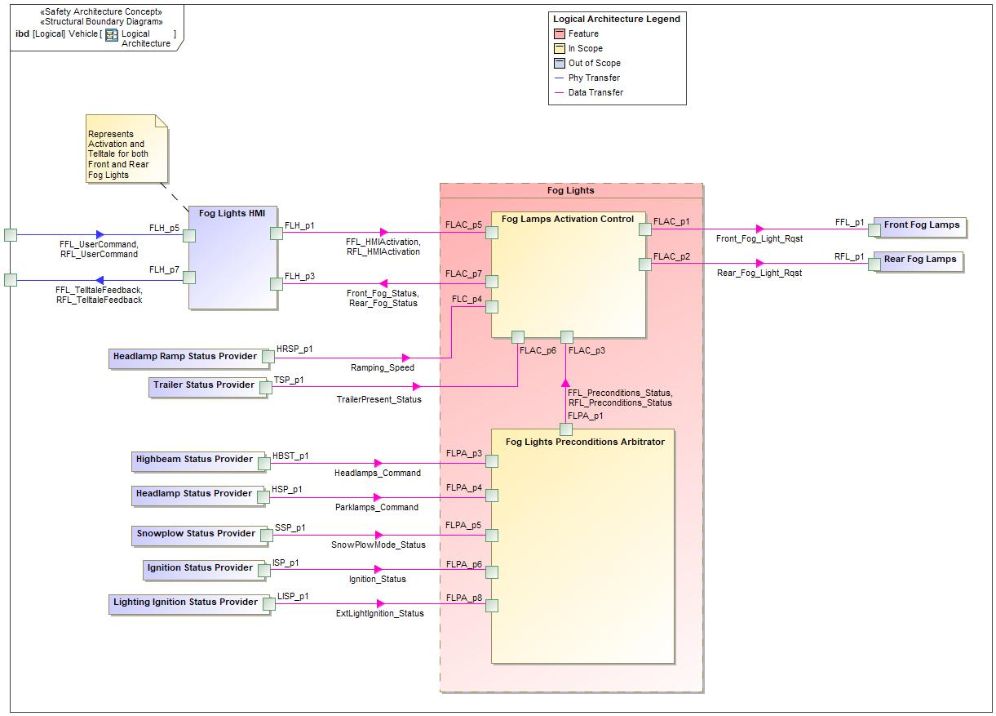

Figure 7: Logical Architecture

### Logical Elements

**#Hint:** Lists the elements of the Logical Architecture and the functions from the Functional Architecture, which are allocated to those elements.

|  |  |  |  |
| --- | --- | --- | --- |
| **Element Name** | **Description** | **Allocated Functions** | **Comments** |
|  |  |  |  |
| Fog Lamps Activation Control | This logical element determines when the Front and Rear Fog Lights must to be turn on or off. |  |  |
| Fog Lights HMI | This logical element represents any way the user interacts with the feature for activation and to receive feedback. For example: hard or soft buttons. | * FFL HMI Activation * RFL HMI Activation * FFL HMI Feedback * RFL HMI Feedback |  |
| Fog Lights Logical | This logical element represents the feature Fog Lights. | * Fog Lights Preconditions Arbitrator * Fog Lamps Activation Control |  |
| Front Fog Lamps | This logical element represents the Front Fog Lights controller. | * Front Fog Lamps Controller |  |
| Headlamp Ramp Provider | This logical element represents the inner components of the vehicle that determines the Headlamp Ramp. | * Provide RampingSpeed Status |  |
| Headlamp Status Provider | This logical element represents the inner components of the vehicle that determines the Headlamp HMI status. | * Provide Headlamp Status |  |
| Highbeam Status Provider | This logical element represents the inner components of the vehicle that determines the Highbeam status. | * Provide Highbeam Status |  |
| Ignition Status Provider | This logical element represents the inner components of the vehicle that determines the ignition status. | * Provide Ignition Status |  |
| Lighting Ignition Status Provider | This logical element represents the inner components of the vehicle that determines the Exterior Lighting Ignition status. | * Provide Exterior Light Ignition Status |  |
| Preconditions Arbitrator | This logical element determines if preconditions for Front and Rear Fog Lights are met. |  |  |
| Rear Fog Lamps | This logical element represents the Rear Fog Lights controller. | * Rear Fog Lamps Controller |  |
| Snowplow Status Provider | This logical element represents the inner components of the vehicle that determines the Snowplow status. | * Provide Snowplow Status |  |
| Trailer Status Provider | This logical element represents the inner components of the vehicle that determines the Trailer status. | * Provide Trailer Status |  |

Table : Logical Elements

### Logical Interfaces

**#Hint:** Describe the interactions of the feature with other features or elements.

|  |  |  |  |
| --- | --- | --- | --- |
| **Interface** | **Direction** | **Description** | **Value Range** |
| ExtLightIgnition\_Status | LISP\_p1 (Lighting Ignition Status Provider) To FLPA\_p8 (Preconditions Arbitrator) | Exterior Light Ignition Status information according to vehicle's engine status. |  |
| FFL\_HMIActivation | FLH\_p1 (Fog Lights HMI) To FLAC\_p5 (Fog Lamps Activation Control) | Signal sent when Front Fog Lights HMI is actuated. |  |
| FFL\_Preconditions\_Status | FLPA\_p1 (Preconditions Arbitrator) To FLAC\_p3 (Fog Lamps Activation Control) | Signal that transport information about Front Fog Lights Preconditions. |  |
| FFL\_TelltaleFeedback | FLH\_p7 (Fog Lights HMI) To p3 (Vehicle) | Visual feedback to the user about the state of the Front Fog Lights. | FFL\_TelltaleFeedback  -ON  -OFF |
| FFL\_UserCommand | p1 (Vehicle) To FLH\_p5 (Fog Lights HMI) | User request to activate/deactivate Front Fog Lights. |  |
| Front\_Fog\_Light\_Rqst | FLAC\_p1 (Fog Lamps Activation Control) To FFL\_p1 (Front Fog Lamps) | Front Fog Lights (Feature) output signal. |  |
| Front\_Fog\_Status | FLAC\_p7 (Fog Lamps Activation Control) To FLH\_p3 (Fog Lights HMI) | Signal that indicates the status of Front Fog Lights. | Front\_Fog\_Status  -ON  -OFF |
| Headlamps\_Command | HBST\_p1 (Highbeam Status Provider) To FLPA\_p3 (Preconditions Arbitrator) | Signal that transports information about Headlamps HMI position/value. |  |
| HSP\_p1 (Headlamp Status Provider) To FLPA\_p4 (Preconditions Arbitrator) | Signal that transports information about Headlamps HMI position/value. |  |
| Ignition\_Status | ISP\_p1 (Ignition Status Provider) To FLPA\_p6 (Preconditions Arbitrator) | Signal that indicates the status of the ignition according to vehicle's engine. | Ignition Status -Off -ACC -RUN |
| Parklamps\_Command | HSP\_p1 (Headlamp Status Provider) To FLPA\_p4 (Preconditions Arbitrator) | Signal that informs the status of the headlamps. | Headlamp Status  -OFF  -PARKING/POSITION  -LOWBEAM  -AUTO |
| Ramping\_Speed | HRSP\_p1 (Headlamp Ramp Provider) To FLC\_p4 (Fog Lamps Activation Control) | Signal that indicates the value of the ramping speed in order to determinate the on and off delay for Front Fog Lights. | Ramping\_Speed  -IMMEDIATELY  -FAST  -SLOW  -MEDIUM |
| HRSP\_p1 (Headlamp Ramp Provider) To FLPA\_p3 (Preconditions Arbitrator) | Signal that indicates the value of the ramping speed in order to determinate the on and off delay for Front Fog Lights. |
| Rear\_Fog\_Light\_Rqst | FLAC\_p2 (Fog Lamps Activation Control) To RFL\_p1 (Rear Fog Lamps) | Rear Fog Lights (Feature) output signal. |  |
| Rear\_Fog\_Status | FLAC\_p7 (Fog Lamps Activation Control) To FLH\_p3 (Fog Lights HMI) | Signal that indicates the status of Rear Fog Lights. | Rear\_Fog Status  -ON  -OFF |
| RFL\_HMIActivation | FLH\_p1 (Fog Lights HMI) To FLAC\_p5 (Fog Lamps Activation Control) | Signal sent when Rear Fog Lights HMI is actuated. |  |
| RFL\_Preconditions\_Status | FLPA\_p1 (Preconditions Arbitrator) To FLAC\_p3 (Fog Lamps Activation Control) | Signal that transport information about Rear Fog Lights Preconditions. |  |
| RFL\_TelltaleFeedback | FLH\_p7 (Fog Lights HMI) To p3 (Vehicle) | Visual feedback to the user about the state of the Rear Fog Lights. | RFL\_TelltaleFeedback  -ON  -OFF |
| RFL\_UserCommand | p1 (Vehicle) To FLH\_p5 (Fog Lights HMI) | User request to activate/deactivate Rear Fog Lights. |  |
| SnowPlowMode\_Status | SSP\_p1 (Snowplow Status Provider) To FLPA\_p5 (Preconditions Arbitrator) | Signal that transports information about the status of Snowplow feature. | SnowPlowMode\_Status  -ENABLE  -DISABLE |
| TrailerPresent\_Status | TSP\_p1 (Trailer Status Provider) To FLAC\_p6 (Fog Lamps Activation Control) | Signal that transports information about the status of Trailer presence. |  |

Table 23: Feature Interactions











# Traceability Matrix

**#Hint:** The traceability matrix is ideally generated from a Requirement Management tool (e.g. VSEM RM) once the specification is imported to the tool and all trace links are drawn in the tool.

**#Link:** Refer to “Backward Traceability” at [Stages – RE Traceabilty Record](https://bd101001.pd2.ford.com/stages/" \l "/workspace/209/_vv/(process/artifact/_ZbIhsK4EkzaN49uPh7SLuQ))

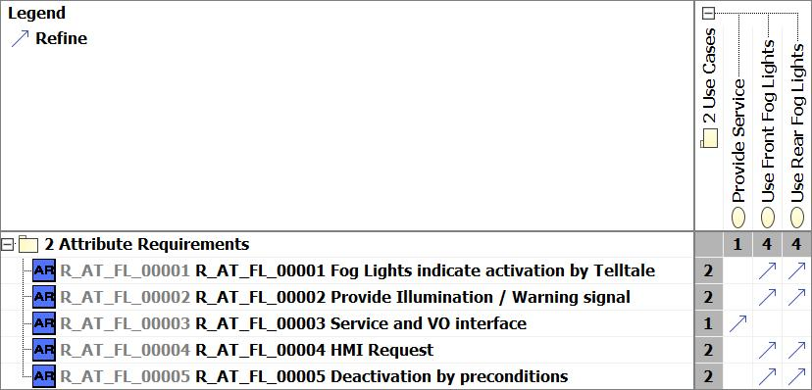

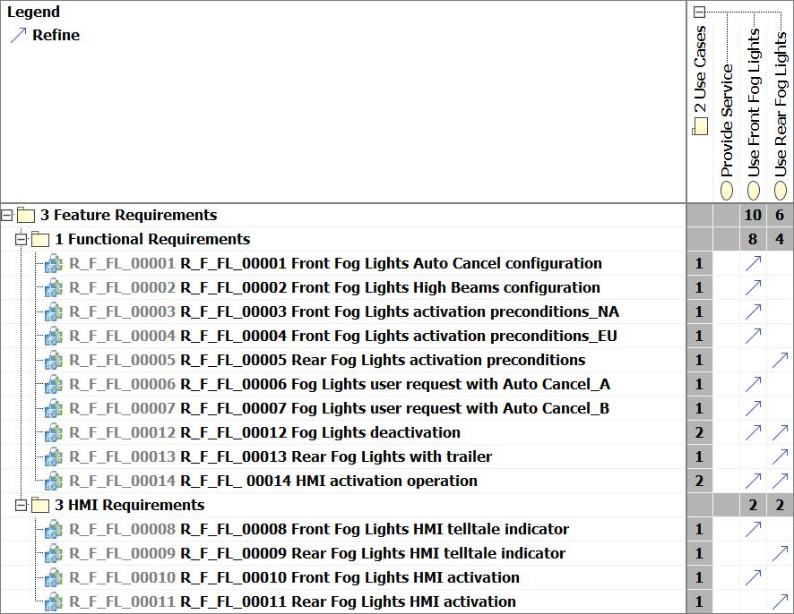

# Open Concerns

**#Hint:** The following list presents open concerns, which have to be discussed or clarified over the course of the on-going requirements engineering.

| ID | Concern Description | e-Tracker / Reference | Responsible | Status | Solution |
| --- | --- | --- | --- | --- | --- |
| 1 |  |  |  |  |  |
| 2 |  |  |  |  |  |
| 3 |  |  |  |  |  |
| 4 |  |  |  |  |  |
| 5 |  |  |  |  |  |
| 6 |  |  |  |  |  |
| 7 |  |  |  |  |  |
| 8 |  |  |  |  |  |
| 9 |  |  |  |  |  |

Table 24: Open Concerns

# Revision History

## Template Revisions

*#Important: Do not change this section*

No revision history found.

# Appendix

Document ends here.